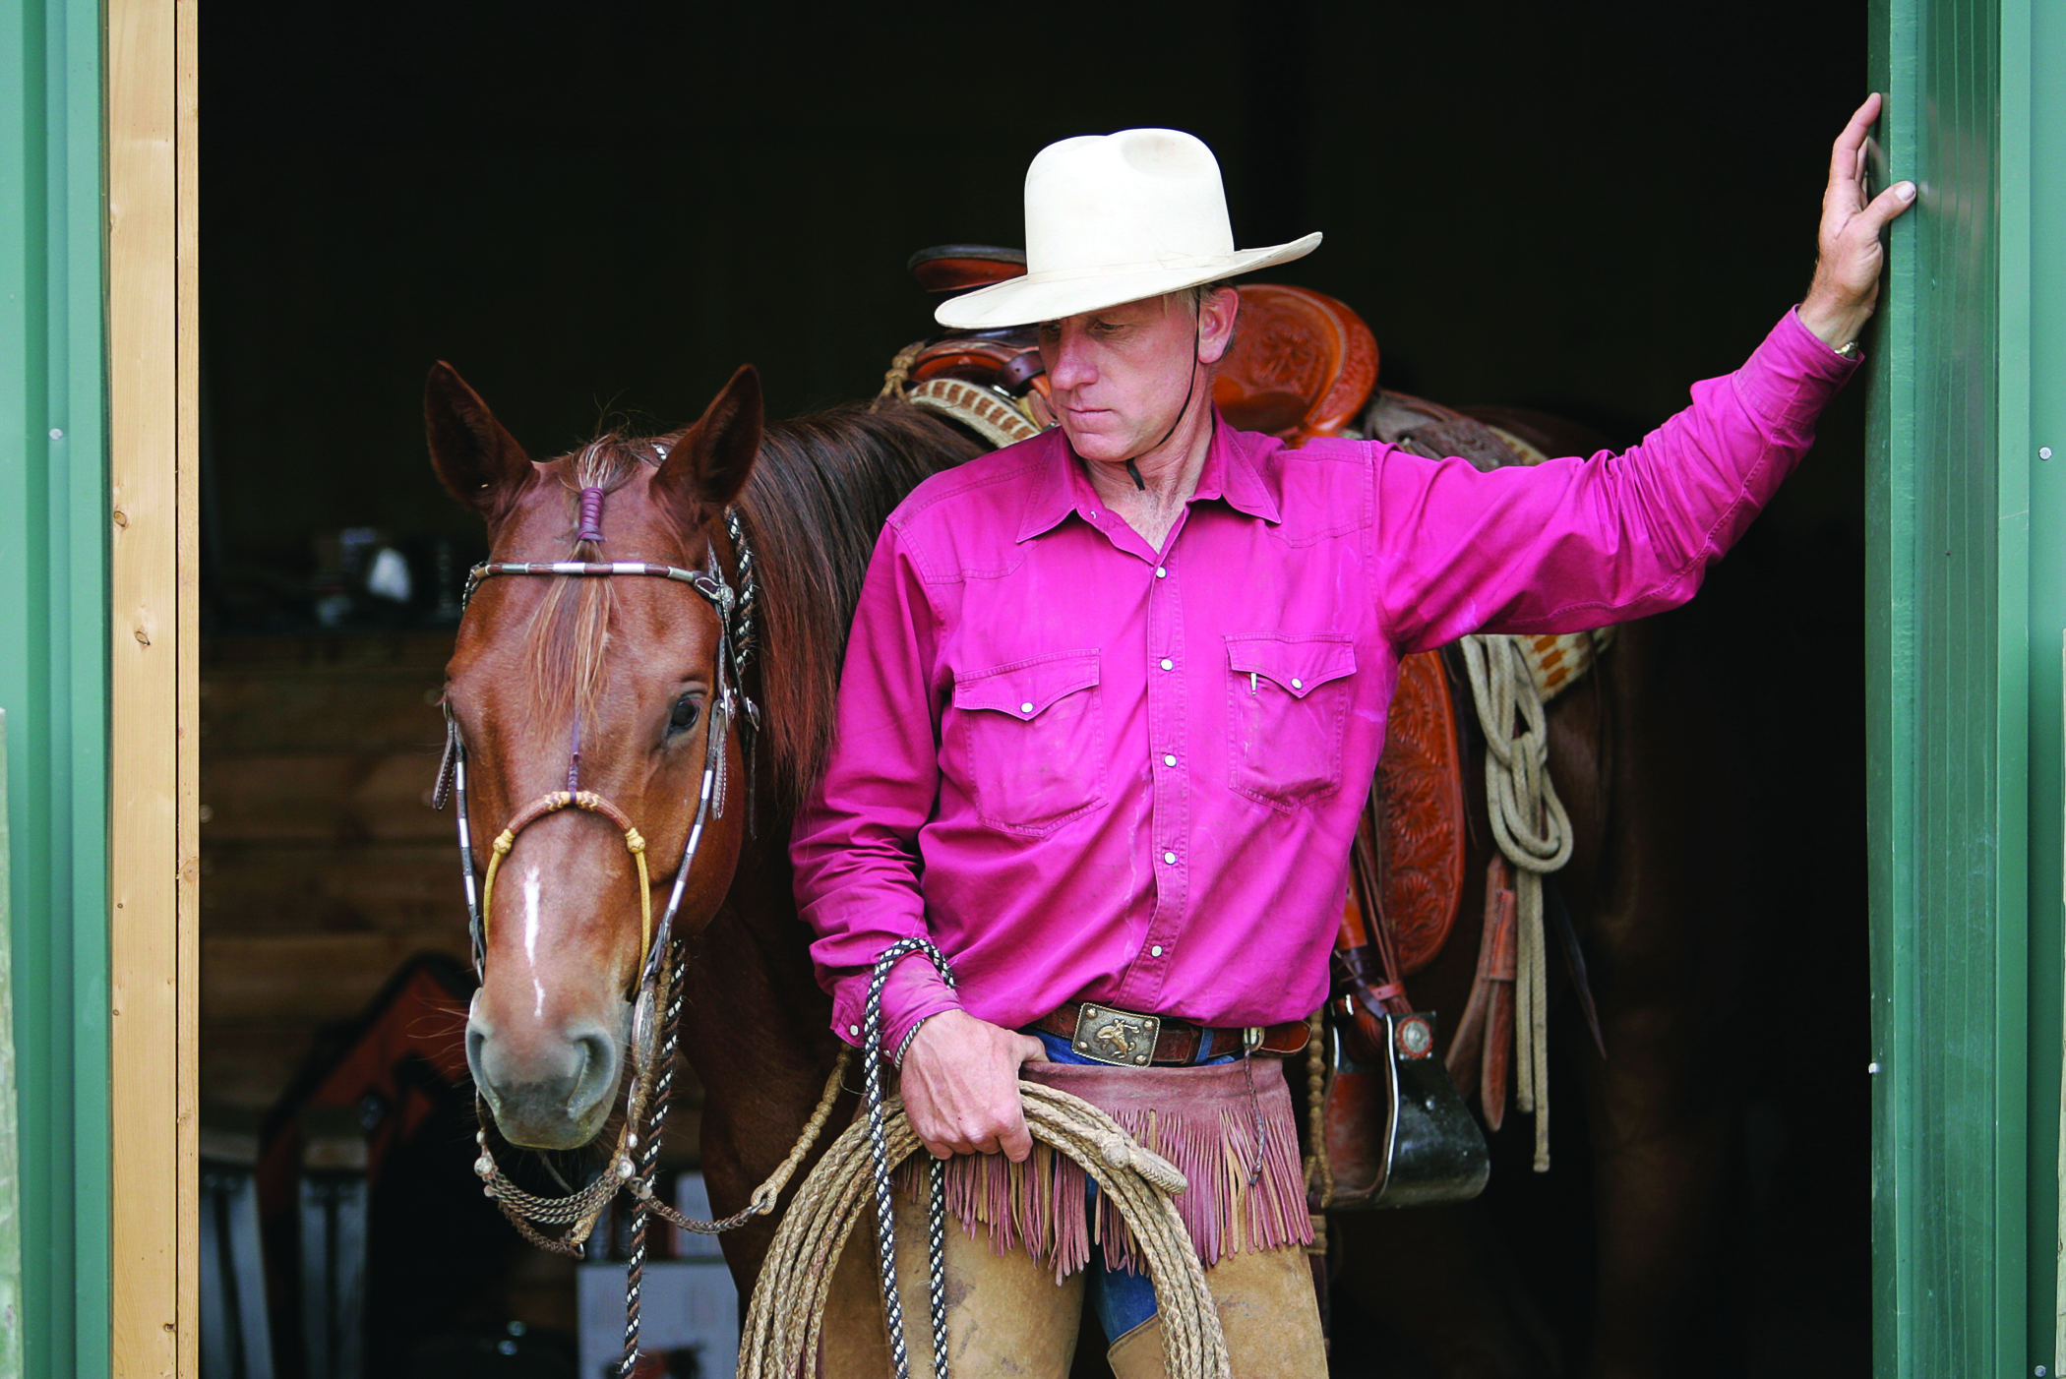  BUCK BRANNAMAN  CLINIC  ROLLING HILLS EQUESTRIAN  CENTER  2655 EVERETT FREEMAN WAY CORNING, CA  MAY 3-5, 2019  FOUNDATION HORSEMANSHIP 9:00-12:00  HORSEMANSHIP 1 1:30-4:30  MAY 11-13, 2019  HORSEMANSHIP 1 9:00-12:00  RANCH ROPING 1:30-4:30  NO VIDEO ALLOWED | UNLIMITED SPECTATOR SEATING AVAILABLE  SPECTATOR FEE $30.00  KIDS 12 &UNDER AND SENIOR CITIZENS FREE  FOOD AND COFFEE WILL BE AVAILABLE  HOTEL INFO:  The Lodge  530-824-3220  The Inn  530-824-8300  OFF SITE:  Holiday Inn Express 888-477-9151  Best Western  530-824-5200  CLINIC SPONSOR  Tina Cornish  530-680-6924  www.thepinecreekranch.weebly.com  Tina Cornish  3445 Meridian Road  Chico, CA 95973  530-680-6924  Web Address  Dates and Times
No Video Allowed

